**OFAC Analysis**

The Office of Foreign Assets Control (OFAC) of the US Department of Treasury administers and enforces economic and trade sanctions against targeted foreign states, organizations, and individuals based on U.S. foreign policy and national security goals. The Specially Designated Nationals (SDN) List published by OFAC details the individuals and organizations with whom United States citizens and permanent residents are prohibited from conducting business. There are three separate files that detail “Name”, “Alternate Name” (another name the SDN may be known as), “Address”, and “Country” information for the targeted entities.

To perform the analysis, follow these steps:

1. Obtain the vendor, customer, and employee information from the Liz systems. You can request this information from Donald Reed (JDE), Ramesh Gandham (SEWN), and Tricia Del Greco (PeopleSoft):
   1. JDE Vendors and Customers - The file obtained should include the following fields: JDE Number, Vendor Name, Address, City, State, Zip, Country, and Account Type. Note, the “Account Type” field denotes whether the record is a customer (C) or a vendor (V). Here is the file obtained during the first review.
   2. SEWN Vendors - The file obtained should include the following fields: Supplier ID, Supplier Name, Brand Group ID, Brand Description, Sales Company, Address 1, Address 2, City, State Province Code, Zip Code, and Country Code. Here is the file obtained during the first review.
   3. SEWN Customers – The file should include the following fields: Customer ID, Customer Name, Brand Group ID, Brand Description, Sales Company, Address 1, Address 2, City, State Province Code, Zip Code, and Country Code. Here is the file obtained during the first review.
   4. PeopleSoft Employees – The file should include the following fields: ID, Name, Address 1, Address 2, City, State, Postal, and Country. Here is the file obtained during the first review.
2. Obtain the lasted OFAC data from the Treasury’s website located at:

<http://www.treasury.gov/resource-center/sanctions/SDN-List/Pages/default.aspx>

Download the three files named SDN.pip, ADD.pip, and ALT.pip. Note, these are the pipe (“|”) delimited text files, which are easy to import into excel.

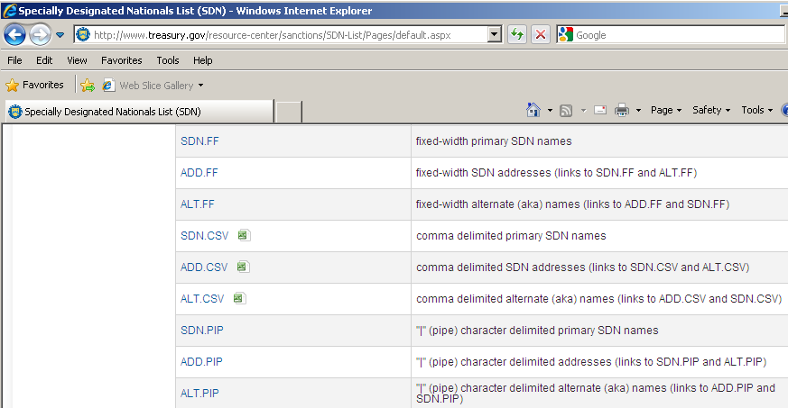

1. Once you’ve collected all of the data in steps 1 and 2 above, you need to copy all of it into the OFAC template workbook. It’s a good idea to create a separate workbook for 1.a, 1.b, 1.c, and 1.d. Within each workbook there should be 4 worksheets:
   1. A worksheet containing the data from 1.a, 1.b, 1.c or 1.d.
   2. A worksheet containing the data in the SDN.pip file.
   3. A worksheet containing the data in the ADD.pip file.
   4. A worksheet containing the data in the ALT.pip file.

So, the workbook should look like this:

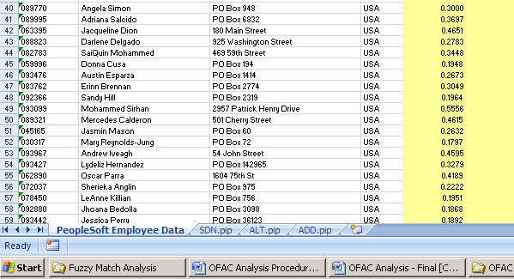

In order to import the pipe-delimited OFAC files, you need to use Excel’s Data -> Import function. Specify “Delimited”:

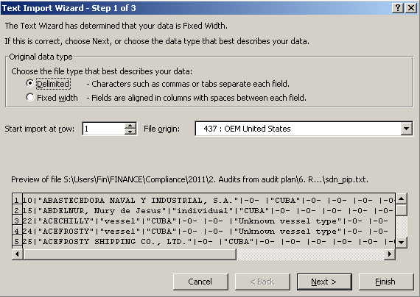

And specify the pipe character (shift \):

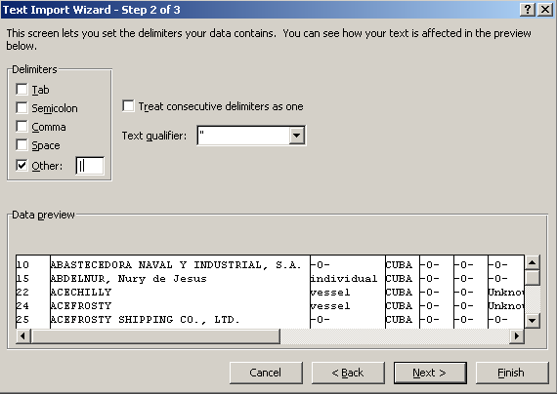

1. Now that the data is all set up it’s time to run the macro to perform the analysis. The methodology used is a “fuzzy” matching algorithm to develop a score and rank how close a supplier, customer, or employee matches an SDN entity across 4 categories – “Name”, “Alternate Name”, “Address”, and “Country”. The fuzzy matching algorithm compares two strings and returns a value between 0 and 1 for how closely the two strings match each other with 1 being a perfect match and 0 being no match (e.g. having no characters in common). The fuzzy matching algorithm is visual basic code in Excel that is run as a macro.

Using this methodology across the 4 categories an overall score can be developed for how close a Liz entity matches one of the SDN entities by simply summing the returned fuzzy matching results for each category. An overall score between 0 and 4 is calculated with 4 being a perfect match for “Name”, “Alternate Name”, “Address”, and “Country” and 0 being no match on any category. As a visual example, here’s a snippet of data from one of the analysis files:

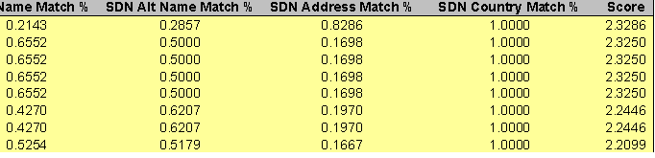

You need to run the fuzzy matching macro and compare the following fields:

* “Vendor/Customer/Employee Name” to “SDN_Name” (from the SDN.pip data)
* “Vendor/Customer/Employee Name” to “Alt_Name” (from the ALT.pip data)
* “Address” to “Address” (from the ADD.pip data)
* “Country” to “Country” (from the ADD.pip data)

To run the macro go to Tools -> Macro -> Macros and click on “FuzzyMatch” (note, in Excel 2007 you need to set the options to view the “Developer” ribbon and then click the Macros button on that ribbon):

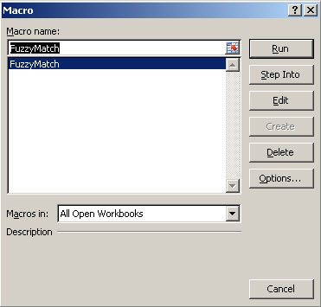

Click “Run” button and the following dialog box appears:

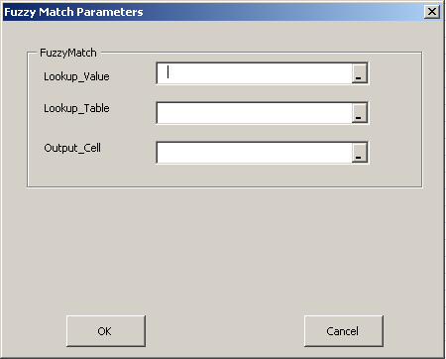

You must enter three parmeters to run the analysis. You can think of this as a juiced vlookup formula. The parameters are as follows:

* Lookup_Value – This is the range of values that you want to find a fuzzy match for. Note, this range must only be one column of data (e.g. C1:C1000 - putting C1:D1000 would result in an error). This will always be the range that contains the “Vendor/Customer/Employee Name”, “Address 1”, or “Country” fields obtained from 1.a, 1.b, 1.c, and 1.d.
* Lookup_Table – This is the range that contains the data you want the Lookup_Value field compared against. Note, this range must only be one column of data (e.g. C1:C1000 - putting C1:D1000 would result in an error). This will always be the range that contains the “SDN_Name”, “ALT_Name”, “Address”, and “Country” from the SDN.pip, ALT.pip, and ADD.pip file obtained in step 2.
* Output_Cell – This is the range where you want the result of the analysis placed. In order to keep things simple always put the results directly next to the Lookup_Value parameter. So, for example, if the Lookup_Value is set to C1:C100 then enter C1 in the Output_Cell parameter to place the results in the adjacent cell.

As a visual example, here is the dialog box filled out to perform the analysis on some of the data in the template:

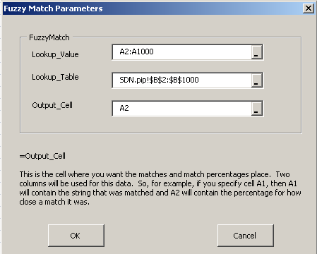

This is going to perform a comparison for each value in rows A2 through A1000 of the current sheet against the values stored in the SDN.pip worksheet in rows B2 through B1000. The code’s execution will look like the following comparison:

A2 -> SDN.pip B2

A2 -> SDN.pip B3

A2 -> SDN.pip B4

A2 -> SDN.pip B5

…

A2 -> SDN.pip B1000

A3 -> SDN.pip B2

A3 -> SDN.pip B3

A3 -> SDN.pip B4

A3 -> SDN.pip B5

…

A3 -> SDN.pip B1000

A4 -> SDN.pip B2

A4 -> SDN.pip B3

And so on to A1000. For each value in the Lookup_Value range it will compare it to all of the values in the Lookup_Table range and return the closest match with a number (between 0 and 1) for how closely they match.

After you fill in these parameters, hit Ok, and the code will execute and look like this:

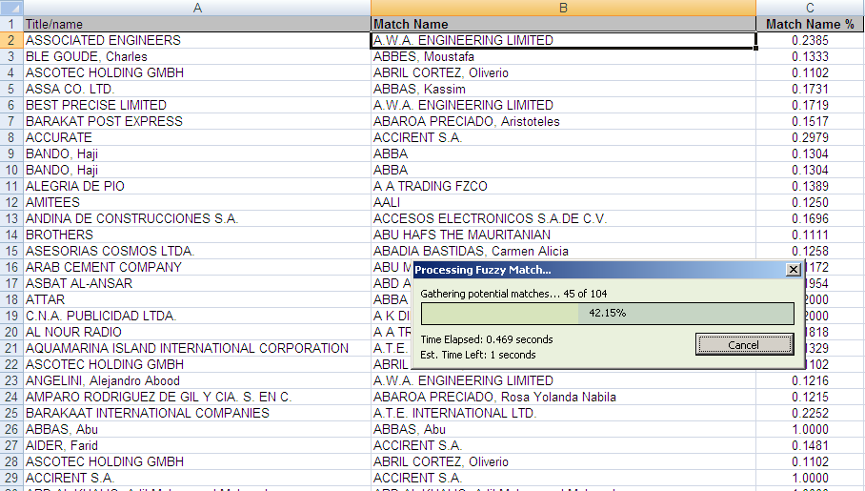

A status dialog box will appear showing you the progress of the comparison. Note, this can take a good amount of time to finish...just let the code execute and complete. When’s it’s done you will have a “Match” and a “Match %” (0 to 1) next to each value in the Lookup_Value range. The “Match” is the value from the Lookup_Table range that was the closest match and the “Match %” is how close the match is.

When you run the four comparisons outlined above you will have 4 “Match %” values. Sum these 4 values to get an overall score. Here are the general rules to follow to identify exceptions:

* An overall score of 3 or greater requires a manual inspection to be able to disqualify the match.
* A fuzzy match returned result of 1.0000 for any category except “Country” requires a manual inspection to disqualify the match.